D I O C E S E O F V A R A N A S I
F U L L N E S S I N T R U T H

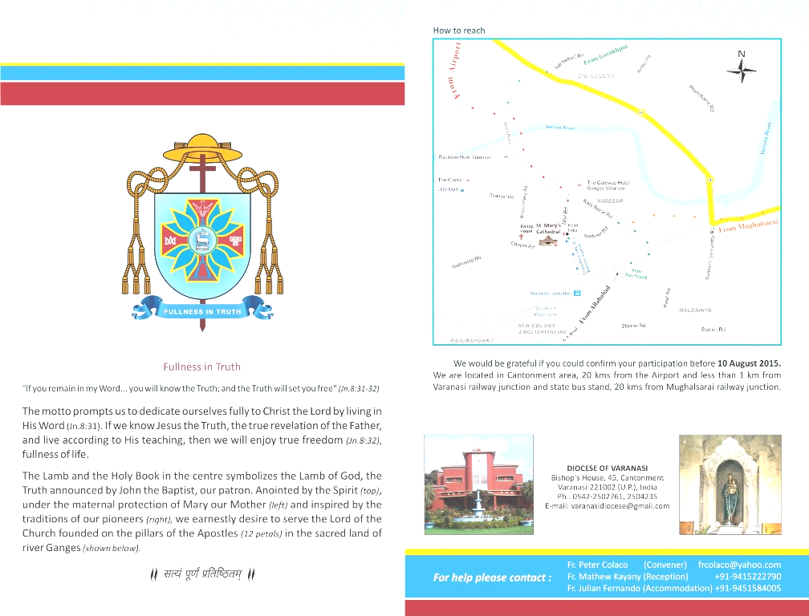

CIR NO. 03/2018 |  | February 13, 2018
  “HER SINS ARE FORGIVEN, FOR SHE LOVED MUCH; HE WHO IS FORGIVEN LITTLE, LOVES LITTLE”  (Lk 7:47) | My dear Fathers, Sisters and Brothers,  Grace, Mercy and Peace of Christ Jesus our Risen Lord !  1. Lent is a new beginning, a favourable time for conversion, a season for deepening our spiritual life through prayer, fasting and almsgiving. Lent summons us to come back to the Lord whole heartedly and in every aspect of our life. We are asked to return to God “with all their hearts” (Joel 2:12) and grow in friendship with the Lord.  In the parable of the rich man and Lazarus (Lk 16:19-31) we can find a key to understanding what we need to do in order to attain sincere conversion. The poor man, wretched, disgraced, pitiful and in great misery is a priceless treasure whom God loves and cares for, despite his condition as an outcast. From Lazarus, meaning ‘God helps’ we learn that other persons are a gift; we need to open the doors of our heart to others and recognizing in them the face of Jesus. Each person we encounter deserves acceptance, respect and love, especially when in weak and vulnerable condition.  The rich man, who does not have a name is opulent, ostentatious about his wealth, “feasted sumptuously everyday” (v 19), is a portrayal of the corruption of sin, caused by love for money, vanity and pride.  For the Apostle Paul, “the love of money is the root of all evils” (I Tim 6:10). Money can be a tyrannical idol (EG.55), it “can chain the entire world to a selfish logic that leaves no room for love and hinders peace” (Pope Francis).  The rich man dresses like a king and acts like a god; his life is imprisoned to outward appearances which masks his interior emptiness; he is blinded to the poor man lying at his door in starvation.
  Programme
  FEBRUARY 2018
Bishop’s House, 45, Varanasi Cantt., U.P. 221 002, INDIA
(0542) 2502761, 2504235; Fax 2502767, E: varanasidiocese@gmail.com; web: dioceseofvaranasi.org

The liturgy of the Ash Wednesday, therefore, invites us to “Remember that you are dust, and to dust you shall return”. In fact, at the root of rich man’s torments after death was his failure to heed God’s word, there was no place for God in his life, rather his only god was himself.

Holy Father Pope Francis, in his Lenten message explains what are we to do for renewing our encounter with Christ during this Season of lent.

The Church, our Mother and Teacher, along with the often bitter medicine of the truth, offers us in the Lenten season the soothing remedy of prayer, fasting and almsgiving.

By devoting more time to prayer, we enable our hearts to root out our secret lies and forms of self-deception, and then to find the consolation God offers. He is our Father and he wants us to live life well.

Fasting weakens our tendency to violence; it disarms us and becomes an important opportunity for growth. On the one hand, it allows us to experience what the destitute and the starving have to endure. On the other hand, it expresses our own spiritual hunger and thirst for life in God. Fasting wakes us up. It makes us more attentive to God and our neighbour. It revives our desire to obey God, who alone is capable of satisfying our hunger.

Almsgiving sets us free from greed and helps us to regard our neighbour as a brother or sister. What I possess is never mine alone. How I would like almsgiving to become a genuine style of life for each of us! How I would like us, as Christians, to follow the example of the Apostles and see in the sharing of our possessions a tangible witness of the communion that is ours in the Church! For this reason, I echo Saint Paul’s exhortation to the Corinthians to take up a collection for the community of Jerusalem as something from which they themselves would benefit (cf. 2 Cor 8:10). When we give alms, we share in God’s providential care for each of his children. If through me God helps someone today, will he not tomorrow provide for my own needs? For no one is more generous than God.

Above all, I urge the members of the Church to take up the Lenten journey with enthusiasm. If, at times, the flame of charity seems to die in our own hearts, know that this is never the case in the heart of God! He constantly gives us a chance to begin loving anew.

One such moment of grace will be, again this year, the “24 Hours for the Lord” initiative, which invites the entire Church community to celebrate the sacrament of Reconciliation in the context of Eucharistic adoration. In 2018, inspired by the words of Psalm 130:4, “With you is forgiveness”, this will take place from Friday, 9 March to Saturday, 10 March. In each diocese, at least one church will remain open for twenty-four consecutive hours, offering an opportunity for both Eucharistic adoration and sacramental confession.

The Lord who overcame the deception of the tempter during the forty days in the desert shows us the path we must take. May the Holy Spirit lead us on a time journey of conversion, so that we can rediscover the gift of God’s word, and be purified of the sins that blinds us (Pope Francis).

Let me draw your attention to an important point Holy Father makes in Misericordia et Misera (MM 11). The Sacrament of Reconciliation must regain its central place in the Christian life. This requires priests capable of putting their lives at the service of the “ministry of reconciliation” (2 Cor 5:18), in such a way that, while no sincerely repentant sinner is prevented from drawing near to the love of the Father who awaits his return, everyone is afforded the opportunity of experiencing the liberating power of forgiveness.

Prayer from the Jewish liturgy book “Gates of Repentance” can inspire us. “Lord, help us to turn from callousness to sensitivity, from hostility to love, from pettiness to purpose, from envy to contentment, from carelessness to discipline, from fear to faith. Turn us around, O Lord, and bring us back towards You. Revive our lives as at the beginning, and turn us towards each other, Lord, for in isolation, there is no life.”

2. Shantidham Ashram will hold annual Charismatic Convention from 03-04 (Friday, Saturday and Sunday) March 2018. Similarly Yesudham will hold convention from 16-18 March 2018. These will be opportunities for deeper spiritual renewal during Lenten season with special focus on the Word of God. Kindly encourage the people to benefit from it.

3. Our Clergy Recollection will be on 21st and 22nd (Wednesday and Thursday) March 2018 beginning at 09.30 am on 21st. The Chrism Mass will be at 5.30 p.m. on 21st March. Kindly bring your holy oil vessels in well-cleansed condition for receiving the new oils.

4. A training programme for the Catechism Teachers of different parishes and institutions in the Diocese is scheduled for April 16 to 18 at Nav Sadhana. All involved in teaching Catechism are expected to attend the programme.

5. I request all the principals/headmasters/boarding incharges to take timely action to ensure new admissions of Catholic children to school as well as boarding.

We must also motivate students to attend summer school of music and dance, BA in Nav Sadhana Kala Kendra, GNM in St. Mary’s Nursing School, Varanasi and Fatima Nursing School, Mau. Some guidance and preparation for entrance test will certainly help them.

6. I earnestly request all to plan in advance the Summer Camp, paying attention to the syllabus, the team of Fathers, Sisters, Teachers, Catechists, etc. Including some creative activities and teaching aids will make the programme enjoyable for boys and girls. Summer camp must be seen as an important pastoral concern of all in the parish and should get due priority over personal work/holidays.

Yours in the Lord,


+Eugene Joseph
Bishop of Varanasi

Encl: Diocesan Lenten Regulations

DIOCESAN LENTEN REGULATIONS
The following are to be made known in Lent to the faithful, including Religious Communities, in all Parishes and missions. What concerns certain feasts etc. should be repeated during the year at the appropriate time.

- Days of Obligation

Regarding Sundays and feast days of obligation, Canon 1246 prescribes ten days of obligation. In India, Christmas and the feast of the Assumption of our Lady are days of obligation. Three feasts, the Epiphany of Our Lord, the Ascension of Christ and the Feast of the Body and Blood of Christ have been transferred to Sundays.

The other five solemnities: Mary Mother of God; the Immaculate Conception; St. Joseph; the Apostles, Ss Peter and Paul; and All Saints are omitted as feast days of obligation in India.

The obligation of assisting at Mass is satisfied whenever Mass is celebrated in any Catholic Rite, either on a holy day itself or in the previous evening (after 4.00 P.M.) of the previous day and on the eve of Christmas and the Assumption.

2. Easter Duties may be fulfilled from Ash Wednesday to Trinity Sunday.

3. Penitential Law

Canon 1251 and the following regulations, prescribe days of penance for the universal Church. By virtue of the powers given by the Decree of February 27, 1996, the CBCI has mitigated the norms.

4. Days of Penance: All the Fridays of the year and the days of Lent.

Since on these days, one is no more bound to abstain from meat, some other penitential work must substitute it. Substitution may be done by one of the following devotional practices and good works, or similar ones:
- Assisting at Mass
- Visit to the Church
- Reception of Holy Communion
- Stations of the Cross
- Almsgiving
- Visiting the poor
- Visiting the sick either at home or in hospitals
- Reading the Bible or a Spiritual Book
- The family Rosary
- Abstaining from going to the picnic/cinema or from smoking /alcoholic drinks
- Bearing sickness or suffering patiently.

The usual faculties for Parish Priests or Confessors are still in force for dispensing or substituting, even in the case of above. See Vademecum.

5. Fast and Abstinence.

Days of Fast and Abstinence: Ash Wednesday and Good Friday. Abstinence become mandatory from the age of 14; fast, from the age of 21 to 60 (Paenitemini IV)

We should teach all to go beyond the law as regards, specially, penance during Lent.

Though the obligation of specific acts of Lenten penance has been removed since some years, the need for Lenten penance remains. On all penitential days, e.g. Lent, Fridays on which fast or abstinence was prescribed in the past, the obligation should be replaced by other mortification, or works of charity or piety. Those who can keep fast are advised to do so. Those who cannot must substitute it by something else.

The law of penance is essential to Christian life. The changes are not a dispensation, but a 'permission to substitute something else, additional and voluntary, which one is not already obliged to do by one's duty or state of life. Those availing themselves of this general dispensation, all including Priests and Religious, are exhorted to make up by voluntary practices, especially during Lent: assisting at Mass; some additional time of prayer, specially meditation; visiting the sick; some voluntary mortification in eating, drinking, smoking, amusements, putting aside for the poor the money thus saved; giving alms more generously to the poor, to charitable works, specially to the "Campaign against Hunger", accepting more patiently, in a spirit of penance, the trials, sickness, sufferings, contradictions of life.

We should make full pastoral use of Lent, through Sunday and other instructions, intensive preparation for Easter Communion of first communicants, of catechumens. Lenten season is eminently suited for adult catechesis. In many places, the Way of the Cross in the villages is very effective.

Let the renewal of Baptismal vows on Holy Saturday be a means of Christian renewal for us and for our people. It should be prepared with a catechesis.

6. The following collections must be made in all the Churches including the Mission Centres, Chapels and sent to the Bishop’s House, Varanasi.

Name of Collection | Occasion | Purpose | Last Date to submit to the Procurator
Holy Childhood | 2nd Sunday February | Poor Children all over the world | 10th March
Maintenance of the Holy See | Easter | Structures of the Holy See | 10th May
Holy Land | Good Friday | For the upkeep of Holy Place in Holy Land | 10th May
Peter’s Pence | Sunday after 29th June (Peter & Paul) | Needs of Holy Father | 10th August
Mission Sunday | Last but one Sunday of October | Evangelization all over the world | 10th November
Pro Afris | Christmas | Missions in Africa | 10th January
St. Peter the Apostle | Sunday after the feast of St. Jean Marie Vianney | Seminarians & Novices in Mission Countries | 10th September
Lenten Campaign | Lenten Season | Hunger and needy of the world | 10th May
Seminarians of the Diocese | Pentecost Sunday | Needs of Seminarians in Diocese | 10th June

On other Sundays of the year and the Feast days of Obligation the collection should be taken for the upkeep of the respective Church. In order to fall in line with the Catholics of the whole world, Lent has been set aside by the CBCI for the Campaign against Hunger and Disease. All the contributions received from the Parishes and Institutions will be forwarded by the Diocese to Caritas India, New Delhi.

7. Distribution of the Eucharist: As per the rule of the Church the approved ordinary and extraordinary Ministers of the Eucharist will distribute Communion with decorum. They shall not pass the ciborium to the devotees to pick the Sacred Host by themselves. They should wear their special dress.

8. For the celebration of the Eucharist in this Diocese, an alb or cassock, and stole are mandatory.

9. Dress for Priests of Agra region:

- The cassock is the usual and official dress for Priests. It should be worn:
- For Liturgical celebration,
- For official functions
- When on duty in School etc.
- Civil Dress: Civil dress may be worn when off duty.

The dress of the Priest manifests his Person and it should be sober and becoming.

“Let us, with confidence approach the throne of grace,
so that we will obtain mercy and grace to help us in our time of need” (Heb 4:16)

